We appreciate the comments from the editor and reviewers and your interest in our work! These valuable suggestions and questions provide us with an opportunity to improve our paper extensively, as part of our resubmission to Biological Psychiatry CNNI.

While responding to one of our reviewers’ questions, we made a final audit of the data and discovered that one participant in the original sample did not meet the inclusion criteria due to their diagnosis: they were diagnosed as having major depressive disorder with severe psychotic symptoms instead of schizophrenia spectrum disorder. This person was thus removed from this revision, and the results were edited accordingly. This change did not impact the significance (and non-significance) of any of the analyses. The resulting changes were marked in blue in the manuscript. In our response letter, reviewer comments are in black font, our responses in blue font, and manuscript edits in red font.

**Reviewer Comments:**  
  
**Reviewer 1:** Comments to authors:  
  
*Thank you for the opportunity to review "Multivariate Association between Functional Connectivity Gradients and Cognition in Schizophrenia Spectrum Disorders" by Yu and colleagues. The manuscript describes a functional imaging study looking at the relationship between connectivity and clinical symptoms in schizophrenia symptom disorders. The authors use connectivity gradients as a frame of reference and relate individual differences in gradient positions to individual differences in cognitive scores. The study asks an interesting question, but as I outline below, the methods are indirect and it is unclear what biological inferences can be made from them.*  
*(1) The main obstacle is the transformation to gradient space. I understand that this is a popular method in the literature, but the drawbacks are evident here. Namely, the results of the analysis are that some regions climb up or down in these putative hierarchies, and that this is related to individual differences in cognition. Are these changes related to anatomical connectivity? Are they related to changes in intracortical myelin, as the authors posit? At the end of the paper, I was not sure what the main result was, and this is an inherent problem in these studies that seek to identify gradient "compression" or "expansion". Why not just focus on the original functional connections that at least have some direct correspondence with the feature studied (connectivity)?*

We thank the reviewer for these important questions.

We agree with the reviewer’s concern regarding the interpretability of gradient analysis. Gradient analysis provides a multivariate framework that has rich literature (1–3) supporting the interpretation of the dimensions (i.e., the gradients), where their correlations to biology (e.g., myelination) were used. Benefits of the gradients include that they are well-represented developmentally (4, 5) and evolutionarily (6) and can provide a summary metric relating to the organization of brain networks. While a specific interpretation of what a gradient score represents may be open to debate, it appears that a higher gradient score represents a greater separation of specific aspects of network connectivity. Under this interpretation, the gradients provide us a summary metric of an important network property, specifically how much certain sets of networks are properly segregated. A gradient compression suggests less segregation and more cross-talk among sets of networks represented by those gradients.

The gradient score offers complement to traditional network connectivity analysis. For one, it measures the overall property of the network, rather than specific connections. Relatedly, this allows each individual to differ in connections contributing to an expanded or compressed gradient (i.e., greater or lesser segregation across network systems). Brain and behavioral heterogeneity are well-established in psychiatric populations, so summary scores capturing broad network properties may provide information that is not well represented in group analysis of specific networks or connections. Finally, and also relatedly, the gradient scores allow a substantial reduction in the number of dimensions; an analysis of all connections would represent over 64,000 variables, while gradient analysis can reduce to a small handful of variables (e.g., 3). We lose some specificity in doing so but gain the ability to detect distributed changes which may not be well represented in a linear analysis of individual connections. Relative to other data reduction approaches, gradient analysis facilitates the interpretation of dimensions as there is an established gradient set and literature built around them; this strength stands out as the interpretations of dimensions extracted from other component-based analyses of functional connectivity are often more subjective and data-driven. However, we did recognize the limitation of gradient analysis: although it provides a meaningful framework, the results are only meaningful under such a framework and might be hard to generalize back to the observed data.

The relationships between gradients and anatomical changes and myelination, although suggested by correlated patterns in previous studies (1–3), were not tested in this study. Therefore, we included it as one of the discussion points that need to be tested in future analysis. We hope to pursue this hypothesis in the future.

We have added the following sentence in the **Introduction** and **Discussion** to clarify this:

In **Introduction:**

“Human behaviors and cognitions are often generated from the coordinated functioning of different brain regions (4), which is closely linked to the geometry of brain (5). Gradient analysis provides a multivariate framework where the dimensions (i.e., the gradients) are aligned with geodesic brain features (3) and are found meaningful biologically (6–8), developmentally (9,10), and evolutionarily (11). These extracted gradient scores represent the organization of brain regions along hierarchical levels which map onto different levels of cognition, with higher gradient scores in opposite directions representing greater segregation of networks along the corresponding hierarchical network level. When represented by a scatter plot, the lower segregation is represented by networks having gradient scores closer to 0 on the axes resulting in a lower variance of the overall gradient scores, thus called ‘gradient compression.’ With such interpretation, gradient analysis has been used to examine how functional connectivity relates to cognition; e.g., creativity performance (12) and semantic cognition (13,14), where the neurocognitive system of semantic cognition was found also to regulate social cognition (15). By using such gradient technique to examine functional connectivity of SSDs, recent studies found that, compared to Controls, people with SSDs feature unimodal-multimodal (1,16,17) and visual-sensorimotor (1,18) gradient compressions with the unimodal-multimodal gradient compression correlating with clinical symptoms (1,17) and lower processing speed (17). As people with SSDs vary extensively in symptoms (19), treatment response (20,21), cognition (22,23), and brain activity (24–26), gradient analysis provides a general principle of quantifying functional brain organization to investigate individual differences in brain configurations of SSDs while accounting for heterogeneous brain features, which relate to treatment responses (27) and psychotic symptoms (1,17,27) of people with SSDs.” – p. 3

3. Margulies DS, Ghosh SS, Goulas A, Falkiewicz M, Huntenburg JM, Langs G, *et al.* (2016): Situating the default-mode network along a principal gradient of macroscale cortical organization. *Proc Natl Acad Sci* 113: 12574–12579.

4. Park H-J, Friston K (2013): Structural and Functional Brain Networks: From Connections to Cognition. *Science* 342: 1238411.

5. Pang JC, Aquino KM, Oldehinkel M, Robinson PA, Fulcher BD, Breakspear M, Fornito A (2023): Geometric constraints on human brain function. *Nature* 618: 566–574.

6. Huntenburg JM, Bazin P-L, Goulas A, Tardif CL, Villringer A, Margulies DS (2017): A Systematic Relationship Between Functional Connectivity and Intracortical Myelin in the Human Cerebral Cortex. *Cereb Cortex* 27: 981–997.

7. Huntenburg JM, Bazin P-L, Margulies DS (2018): Large-Scale Gradients in Human Cortical Organization. *Trends Cogn Sci* 22: 21–31.

8. Blazquez Freches G, Haak KV, Bryant KL, Schurz M, Beckmann CF, Mars RB (2020): Principles of temporal association cortex organisation as revealed by connectivity gradients. *Brain Struct Funct* 225: 1245–1260.

9. Dong H-M, Margulies DS, Zuo X-N, Holmes AJ (2021): Shifting gradients of macroscale cortical organization mark the transition from childhood to adolescence. *Proc Natl Acad Sci* 118: e2024448118.

10. Xia Y, Xia M, Liu J, Liao X, Lei T, Liang X, *et al.* (2022): Development of functional connectome gradients during childhood and adolescence. *Sci Bull* 67: 1049–1061.

11. Froudist-Walsh S, Xu T, Niu M, Rapan L, Zhao L, Margulies DS, *et al.* (2023): Gradients of neurotransmitter receptor expression in the macaque cortex. *Nat Neurosci* 26: 1281–1294.

In **Discussion:**

“This study examined gradients from the resting-state functional connectivity of SSDs and Controls, using PLSC to explore multivariate associations with social and non-social cognition. Gradients offer an advantage of prior work focused on functional connectivity strength, as the gradient analysis considers topographical properties of how the brain networks are organized (e.g., in terms of well or poor segregation between unimodal and multimodal networks) with strong consensus among researchers on the interpretation of the extracted gradient dimensions (6-8).

[...]

**Limitation**

[…] Finally, as gradient analysis provides one of many multivariate frameworks to decompose and interpret functional connectivity, other multivariate frameworks could yield varied results.” – p. 9-10

1. Huntenburg JM, Bazin P-L, Goulas A, Tardif CL, Villringer A, Margulies DS (2017): A Systematic Relationship Between Functional Connectivity and Intracortical Myelin in the Human Cerebral Cortex. *Cereb Cortex* 27: 981–997.

2. Huntenburg JM, Bazin P-L, Margulies DS (2018): Large-Scale Gradients in Human Cortical Organization. *Trends Cogn Sci* 22: 21–31.

3. Blazquez Freches G, Haak KV, Bryant KL, Schurz M, Beckmann CF, Mars RB (2020): Principles of temporal association cortex organisation as revealed by connectivity gradients. *Brain Struct Funct* 225: 1245–1260.

4. Dong H-M, Margulies DS, Zuo X-N, Holmes AJ (2021): Shifting gradients of macroscale cortical organization mark the transition from childhood to adolescence. Proc Natl Acad Sci 118: e2024448118.

5. Xia Y, Xia M, Liu J, Liao X, Lei T, Liang X, et al. (2022): Development of functional connectome gradients during childhood and adolescence. Sci Bull 67: 1049–1061.

6. Froudist-Walsh S, Xu T, Niu M, Rapan L, Zhao L, Margulies DS, et al. (2023): Gradients of neurotransmitter receptor expression in the macaque cortex. Nat Neurosci 26: 1281–1294.

* References (1-6) are also (6-11) in the manuscript.

*(2) Please cross-validate the PLS model. As the authors are probably aware, these models tend to overfit and permutation tests on their own do not provide enough evidence that the model would generalize.*

We thank the reviewer for this suggestion, which allows us to address this important issue in using PLSC. We performed standard 10-fold cross-validation to examine the reliability; furthermore, to avoid over-estimation with a high train-test ratio (90-10), we also performed a 4-fold cross-validation, which put the train-test ratio at (75-25). The manuscript has been revised as follows:

The **Methods** section was revised as:

“This allows identification of variables which significantly contribute to each dimension. The effect sizes of variables were quantified by their contributions, computed as squared loadings, to determine the importance of each variable to each dimension. We further verified the PLSC model with 10-fold and 4-fold cross-validations (see **Supplementary Materials**).” – p. 7

We have modified the **Results** section as follows:

“Overall, this network hierarchy–cognition association, identified by the first dimension of PLSC, is driven by contributing ROIs, which also happened to show lower differentiation along all three gradients. For instance, PLSC identified ROIs from SMN, VIS2, DMN and Thalamus, which in SSDs showed lower differentiations on Gradient 1 (unimodal vs. multimodal networks). For Gradient 2 (visual vs. auditory networks), PLSC identified ROIs from CON, AUD, SMN, FPN, VIS2, and DAN, where the lower differentiations of SSDs were found mainly between different perceptual networks; more specifically, between AUD, SMN, FPN, CON and VIS2 with DAN. For Gradient 3 (default vs. frontoparietal networks), PLSC identified ROIs from the perceptual, language, and subcortical networks, where lower differentiations of SSDs were found between the unimodal networks (i.e., VIS and SMN) and LAN versus SUB. This PLSC model is verified by 10-fold (*rmin* = .97) and 4-fold cross-validations (*rmin* = .94) (see **Supplementary Materials** for further details).” – p. 9

We have added the following descriptions of the cross-validation and its results to the **Supplementary Materials**:

**“Reliability of the PLSC model.** To examine the reliability of the PLSC results, we performed standard 10-fold cross-validation (CV). To perform a 10-fold CV, we randomly separated the sample into 10 groups (i.e., *folds*) with even (or close-to-even) numbers of participants. To ensure that the group structure of the sample in each fold remains unchanged, we first delineated 10 even groups separately from the Controls and the SSDs group and then combined them to create the complete fold. In the CV procedure, one fold (thus 10% of the sample) was left out as the test set, and PLSC was performed on the remaining 90% of the data (i.e., the training set). The resulting PLSC model was then used to predict the 10% out-of-sample. Formally, the prediction includes 2 steps: (1) all variables from the testing set were first normalized by the means and sums of squares of these variables from the training set, and (2) the predicted latent variables of the testing set were computed by multiplying the normalized variables with the corresponding loadings estimated from the training set. This procedure was iterated through all 10-folds and resulted in two sets of the predicted latent variable and 10 sets of loadings for each table.

To evaluate the performance of the CV, we performed two sets of correlations. First, for each table, we tested Pearson’s correlation between the predicted and the observed latent variables. Second, for each table, we computed the mean and standard deviation (SD) of Pearson’s correlations between the observed loadings and the 10 sets of loadings estimated from all testing sets. To avoid over-estimating the CV performance with a high train-test ratio (90%-10%), we also performed a 4-fold CV, where 4, instead of 10, even folds were generated with a lower train-test ratio (75%-25%).”– Supplementary Materials p. 4-5

“***PLSC*** ***cross-validation***

The 10-fold cross-validation showed significant reliability of the PLSC model with high correlations between the original and the predicted latent variables (LV) (Cognitive LV1: *r* = .9997, *p* < .0001, Gradient LV1: *r* = .98, *p* < .0001), and between the original and the predicted loadings (Cognition: *r* across folds = [.98, .99] with the mean (SD) of *r* = .99 (0.0053), Gradient: *r* across folds = [.97, .99] with the mean (SD) of *r* = .98 (0.0078)). The proportion of variance explained by the first PLSC dimension, across all folds, has range = [.64, .69] with a mean (SD) = .67 (.02).

To avoid over-estimation with a high train-test ratio (90-10), we also performed another cross-validation with 4 folds, which put the train-test ratio at (75-25). The reliability was confirmed in this cross-validation with high correlations found in LVs (Cognitive LV1: *r* = .9995, *p* < .0001, Gradient LV1: *r* = .97, *p* < .0001) and in loadings (Cognition: *r* across folds = [.97, .99] with the mean (SD) of *r* = .98 (0.01), Gradient: *r* across folds = [.94, .95] with the mean (SD) of *r* = .95 (0.003)). The proportion of variance explained by the first PLSC dimension, across all folds, has range = [.64, .67] with a mean (SD) = .65 (.01).”– Supplementary Materials p. 6

*(3) Why go back to Pearson correlations after ComBat? Why not just stay with the Z-transformed values?*

We thank the reviewer for this question. We went back to Pearson correlations as per the “brainspace” Python package (<http://brainspace.readthedocs.io>) that we used to extract the gradients. Given that the Python function extracted gradients from the Pearson correlation matrix, we decided to stay in the same space to avoid possible errors due to the Z-transformation. We have added this information in the **Methods** section to explain our approach.

“To quantify network hierarchy, gradient analysis uses a dimension reduction approach to extract principal gradients from a brain connectivity matrix. In the procedure, the data were transformed back to Pearson correlation coefficients after ComBat, and the data for each participant underwent diffusion map embedding (57) using the *BrainSpace* package (58) to extract principal gradients (3), consistent with the approach shown in http://brainspace.readthedocs.io. These gradients capture specific network segregations that contribute to the overall functional connectivity pattern.” – p. 6

*(4) Gradients were aligned to some template via Procrustes rotation. What was this template? Also, how good was the alignment?*

Thank you for the questions. We used the gradient map derived by Margulies et al. (PNAS, 2016) as the template. To assess the goodness of alignment, we computed the Pearson coefficients of correlation between the gradient scores of each participant and those from the Margulies 2016 gradient map for all 10 extracted gradients. The distributions of the correlation coefficients of all extracted gradients are illustrated by the boxplot below, with the mean (SD) correlation of the first three gradients being .79 (0.07), .64 (0.10), and .74 (0.07).

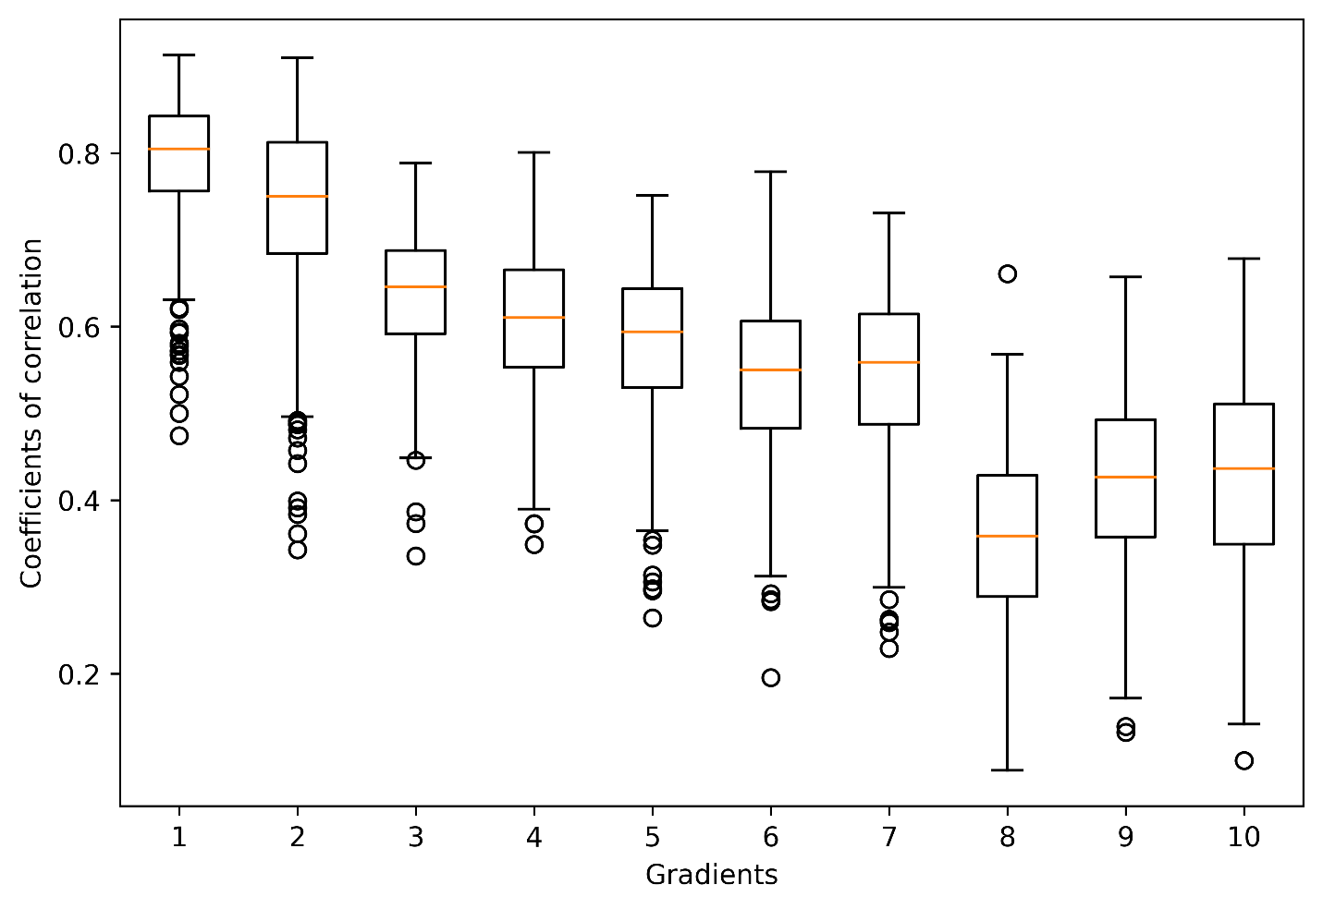

We have also added this figure and the detailed statistics to the **Supplementary Materials** with the caption:

**“Figure S2.** Boxplots of the Pearson’s correlation which quantify the goodness of fit of the Procrustean rotation of each participant to the gradient map from Margulies et al. (2016) for all 10 extracted gradients. The mean (SD) of the coefficients of correlation of each gradient are: .79 (0.07), .74 (0.10), .64 (0.07), .6 (0.08), .58 (0.09), .54 (0.09), .54 (0.09), .36 (0.09), .42 (0.10), .43 (0.11).”

We have added the following sentence to the **Methods** section:

“To allow comparisons between gradients across participants, we aligned them via Procrustean rotation with a template gradient map (3). The goodness of fit of each participant to the template from (3) is illustrated in **Figure S2**. This gradient map reveals the three gradients shown in **Figures 1B-1C**.” – p. 6

**Reviewer 2:** *Comments to authors: In this manuscript Yu et al. take the approach of Marguiles et al. (PNAS 2016) i.e. a framework in which the functional connectivity of the brain can be organized around two (or three) axes with one axis being a visual vs somatomotor gradient and the other being a unimodal versus heteromodal ("sensation vs cognition") gradient. This organization scheme is observed across multiple datasets and even extends to NHPs. Dong et al 2021 demonstrated that these gradients exist in individuals with schizophrenia as expected, but the topology of these gradients is altered: specifically with a compression of gradients such that the range of values in the visual-somatomotor range is shifted away from the most extreme values. Wang et al. 2020 replicated this result and further linked regional hotspots of this compression to a variety of cognitive/clinical factors. Here Yu et al apply this approach to a novel dataset of individuals with schizophrenia spectrum disorders collected at multiple sites with a particular emphasis on social cognitive ability.  
  
Yu et al. are (reassuringly) able to replicate the gradient compression observed by Dong et al. and Wang et al. Furthermore, they do a wonderful job of visualizing the contributions of individual components to the overall compression pattern observed in these studies. Additionally, a multivariate analysis (PLSC) between cognitive performance and clinical symptoms is presented.  
  
Strengths of this paper include the relatively large sample size, careful cognitive characterization of the participants, beautifully informative visual representation of results, and thoroughly described imaging methods. As a fan of publishing replication studies, I'm particularly excited to see that the results of Dong and Wang are being replicated here.*

We thank the reviewer for their interest and positive comments!  
  
*Because these results replicate (and extend) those prior findings, my only concerns are two methodological questions that are shared across all of these papers:  
  
First, I noted that the only motion exclusion was removing 5 (of over 400) participants for excessive motion e.g. mean FD > .05. The mean FD for each group is strikingly low and that's truly admirable for a multi-site study, especially in this population. At the preprocessing stage I don't see any correction for the contribution of micro movements in the FD<.05 range. We do know that these movements directly impact measured functional connectivity (e.g. Power et al 2012) and group comparisons between clinical and typically developing populations are most vulnerable to this kind of confound. Rather than suggest which method of motion correction should be used, I'd like to see visualization of the effects of motion on the gradients described i.e., if one does a median split within-groups e.g. comparing top-half movers to bottom-half movers of individuals with SSD or top-half to bottom-half movers of HC individuals and you map out the trajectories of gradients as in Figure 2, is there movement of the gradient in a direction? Showing that high movement doesn't result in SM->Vis compression would be reassuring.*

We thank the reviewer for the helpful suggestions. To clarify, we used 0.5 mm as the criterion for excessive motion, and FD was regressed out from both the cognitive variables and gradients before entering any analysis. We have clarified this by moving the following sentence that was originally in the paragraph describing our multivariate analysis to avoid confusion:

“[...] Group differences (SSDs-Control) in gradient scores were also examined with two-sample *t*-tests using the linear model approach (i.e., the *lm* function in R) and were corrected for multiple comparisons with a false discovery rate (FDR) approach (*q*<.05). Age, sex, and mean framewise displacement (FD) were regressed out from all behavior and brain measures prior to all analyses. From the linear model, we report the number (*n*) of significant ROIs of each network with their range of *F*-statistics.” – p. 6

We examined the group differences between participants with SSDs and Controls in gradient changes for the top-half movers and the bottom-half movers. Given limited space, we included this analysis in the **Supplementary Material**. The following figure illustrates the results (**A-D** for top-half movers and **E-H** for bottom-half movers) where both groups show similar group differences in all three gradients compared to the overall results (attached below for reference). Although the top-half movers showed more ROIs with significant group effects, the main results (i.e., gradient compression between SM and Vis on Gradient 2) are still strong in the lower-half movers, suggesting a limited confounding effect of motion in the gradient results.

We modified the Result section as follows:

**“Lower Differentiation Across all Three Gradients in SSDs vs. Controls**

[...] Detailed statistics are reported in **Table 2** with ranges of significant *F* statistics and numbers of significant ROIs of each network. Such gradient compression is not confounded by motion, as it appears in both the top-half and the bottom-half movers (see **Supplementary Materials** and **Figures S6-S7**).”– p. 8

The details of the analysis were included in the **Method** section of **Supplementary Material**:

“***Group Differences in all Three Gradients between the SSDs vs. Controls in Relation to Motion***

Given that participants with SSDs are expected to have higher motion in the scanner, we further examined if the group differences between SSDs and Controls are driven by the participants with higher mean framewise displacement (FD). We split the participants into the top-half and the bottom-half movers according to a median split of FD within each participant group. For each half, group differences (SSDs-Control) in gradient scores were examined with two-sample *t*-tests using the linear model approach (i.e., the *lm* function in R) and were corrected for multiple comparisons with a false discovery rate (FDR) approach (*q*<.05).”– Supplementary Materials p. 2

The results of the analysis were detailed in the **Result** section of **Supplementary Material**, along with **Figures S6-S7**:

**“*Lower Differentiation Across all Three Gradients in SSDs vs. Controls for both the Top-Half and the Bottom-Half Movers***

**Figure S6A** illustrates the boxplot of each group from the top-half and the bottom-half movers with descriptive statistics shown in **Figure S6B**. The results from independent two-sample *t*-tests show a significant group difference in mean FD within the top-half movers, *t*(207.34) = 2.56, *p* = .01, but the group difference within the bottom-half movers is not significant, *t*(179.54) = 0.67, *p* = .50. It is worth noting that the effect of mean FD, along with age and sex, has been regressed out from the gradient data for the following analysis.

Significant group differences in gradients across the brain regions are shown in **Figure S7A** and illustrated by arrows representing each region of interest (ROI) in **Figures S7B**-**S7D** pointing from the top-half movers of the Control group to the top-half movers of the SSDs group along all three dimensions. **Figure S7E** showed the same results for the bottom-half movers of the Control group and of the SSDs group with **Figures S7F-S7H** illustrating the changes from the Controls to the SSDs group along all three dimensions. Compared to the overall results, similar patterns of lower differentiation were found in both the top-half and the bottom-half mover groups. They both showed lower differentiations at FDR-corrected *α=*0.05 along all three gradients, with more regions found significant in the top-half mover group. These results suggested that the observed gradient constraints, although affected, were not due to motion effects.”– Supplementary Materials p. 6-7

**Figure S6. Descriptive statistics of the top-half and the bottom-half movers.** **A** illustrates the boxplot of mean framewise displacement (FD) for each group within the top-half and the bottom-half movers. **B** shows the means, the standard deviations (SD), and the ranges of mean FD for each group.

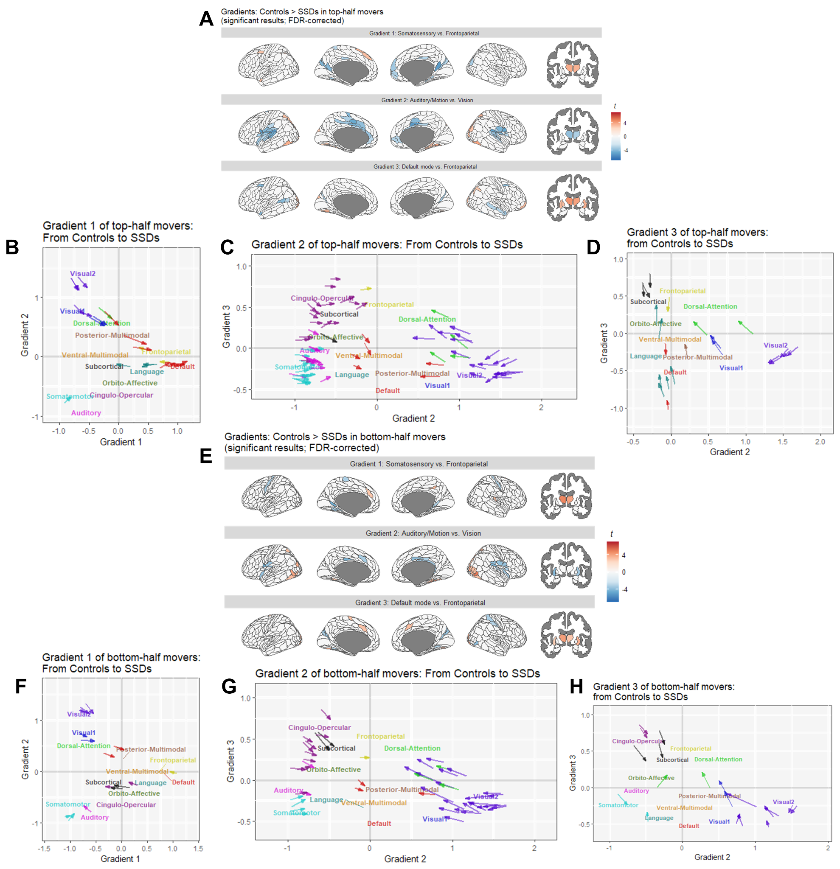

**Figure S7. Group differences in Gradients 1-3 for the top-half and the bottom-half movers. A** shows the brain regions with significant group differences of the top-half movers according to two-sample *t*-tests (as linear models), whereas **E** shows the same results for the bottom-half movers. Warm colors indicate Controls being significantly closer than SSDs to the positive ends of the gradients (i.e., the default/frontoparietal, the visual, and the frontoparietal networks, respectively); cold colors indicate Controls being significantly closer than SSDs to the negative ends of the gradients (i.e., the somatosensory/visual, the auditory/motor, and the default mode networks, respectively). **B**–**D** show the brain regions with group differences between the top-half movers of Controls and the top-half movers of SSDs along Gradients 1–3 in a 3D space; **F**–**H** show the brain regions with group differences between the bottom-half movers of Controls and the bottom-half movers of SSDs along Gradients 1–3 in a 3D space. Significant group differences in a similar set of ROIs were found along Gradient 1 for both the top-half movers (**B**) and the bottom-half movers (**F**), along Gradient 2 (i.e., the x-axis of **C** and **G**) for both the top-half movers (**C**) and the bottom-half movers (**G**), and along Gradient 3 (i.e., the y-axis of **D** and **H**) for both the top-half movers (**D**) and the bottom-half movers (**H**). Each arrow represents one ROI and is colored according to the networks defined by Cole-Anticevic (cortical) and Tian (subcortical) parcellations in **Figure 1A**. The network labels illustrate where the means of the networks are for Controls.

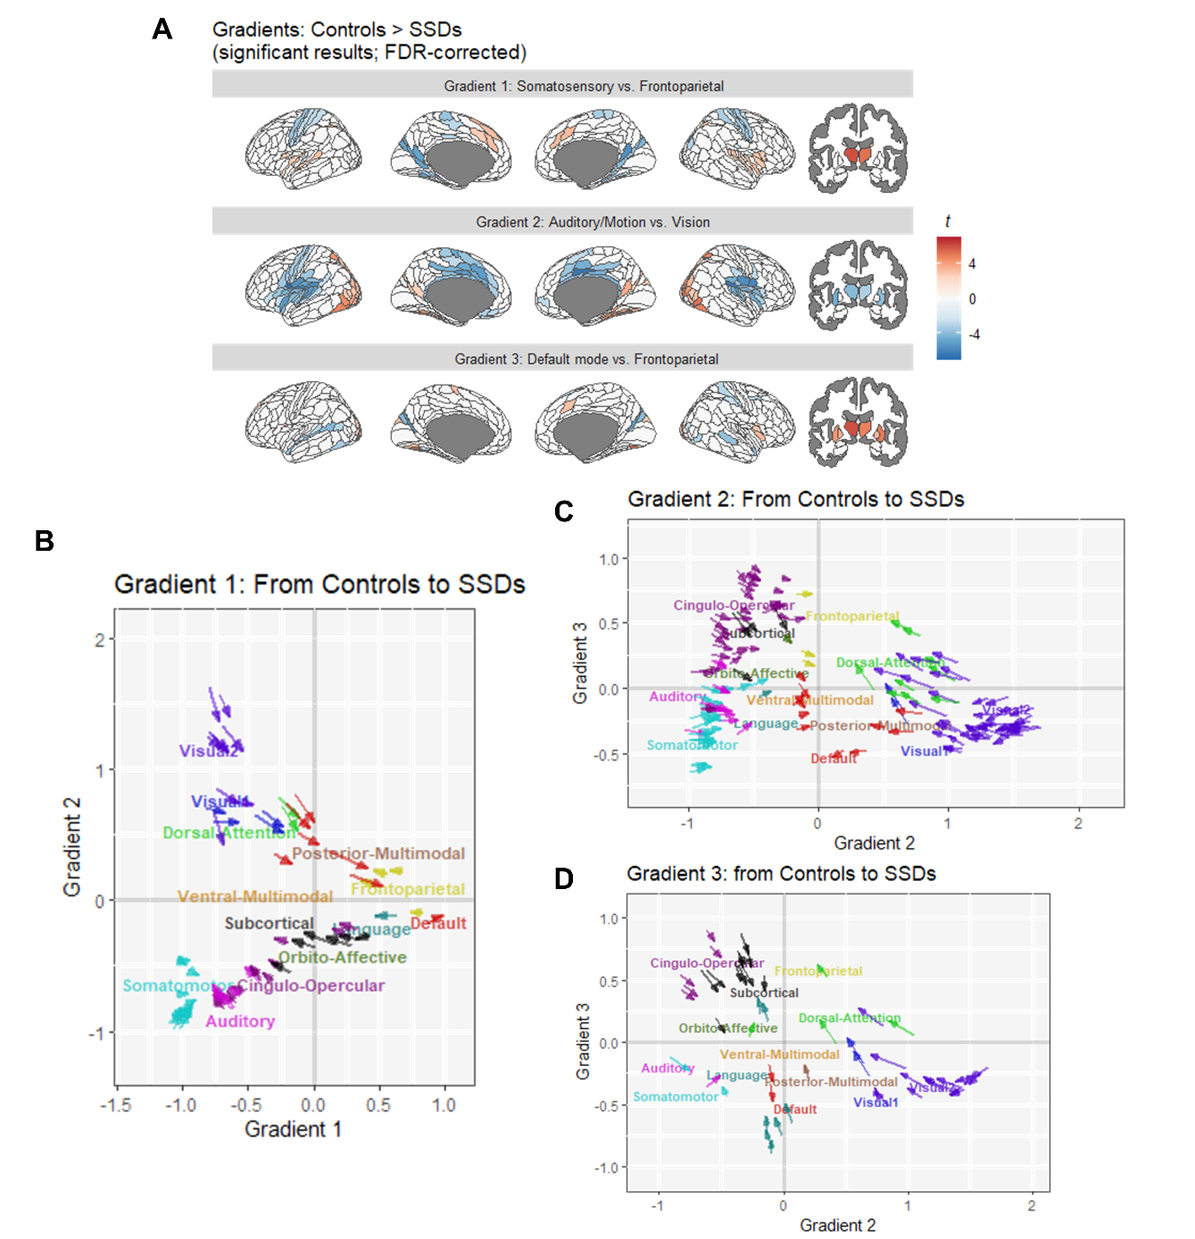

**Group differences in gradients with the complete sample (Figure 2).**

*Second, the analysis showing that the visual->somatomotor axis is compressed is predicated on the idea that the glasser atlas and cole-anticevic brain network parcellation derived from control populations maps accurately onto individuals with SSD. Given the recent suggestion that clinical populations may have differences/expansions of network topography (*[*https://www.biorxiv.org/content/10.1101/2023.08.09.551651v1.full*](https://urldefense.com/v3/__https:/www.biorxiv.org/content/10.1101/2023.08.09.551651v1.full__;!!FxkXuJIC!fJ6mNeavtsbtty1hJUfjtBKGGxY5eYtXp-dcd42PXE961IoffhrW_nGjAh9wxnBNOeGW1C3XWiQtP2E1BQ$)*), how can we determine if the "compression" observed and replicated across studies is not in fact simply an artifact of brain networks in SSD not mapping neatly onto parcels derived from healthy control participants? Is there a brain parcellation that is analogous to the Glasser atlas but derived from SSD participants that could be used instead?*

We thank the reviewer for raising this issue and agree with the reviewer’s concern. There is no available atlas specifically derived for SSDs. Moreover, given the heterogeneity of SSDs as a spectrum disorder, the best approach will be to derive such parcellation from our sample. However, at least 20 minutes of scans are required to derive individualized parcellation. Unfortunately, our scans only include 7 minutes of resting-state scans.

We recognize such limitations and have added the following to the **Discussion**:

“**Limitation**

[…] Additional considerations include the lower signal-to-noise ratio of 7-minute resting-state scans, potential noise from using brain atlases derived from healthy participants (80), and the debated impact of global signal removal. […]” – p. 11

80. Levi PT, Chopra S, Pang JC, Holmes A, Gajwani M, Sassenberg TA, et al. (2023): The effect of using group-averaged or individualized brain parcellations when investigating connectome dysfunction in psychosis. Netw Neurosci 7: 1228–1247.

*Small question for the discussion section: Did the major contributors to group differences (in Figure 2) and the cognitive correlations (Table 2) match with prior published results by Dong et al and Wang et al?*

Thank you for the question! Dong et al. (2021) and Wang et al. (2020) both showed group differences in Gradient 1 with a similar pattern to our findings (see below). However, the group differences found in Wang et al. (2020) were more scattered. Between the two, only Wang et al. (2020) tested the correlations to a cognitive measure (i.e., Category Fluency Test-Animal Naming (CFT) (Strauss et al. 2006) which assesses cognitive performance in processing speed). They found the main cluster correlated with CFT in the superior parietal gyrus (SPG); in our study, this region from Gadient 1 did not contribute significantly to cognitive correlations, but this region from Gradient 2 was identified as one. This difference between our findings and Wang et al. (2020) could be due to several reasons. For example, the contribution of this region might be shadowed when all three gradients are included; the cognitive correlation of SPG might be specific to processing speed but has weaker correlations to social and other non-social cognition; or it might be due to the differences in our SSDs samples, such as in size and other characteristics. The demographic information is not included in the preprint of Wang et al. because they were included in the Supplementary Materials which was not uploaded to *bioRxiv*.

|  |  |
| --- | --- |
| **Dong et al. (2021)** | |
|  | **Figure 2A** |
|  | *Note: The color scale was in the opposite direction* |
| **Wang et al. (2020)** | |
|  | **Figure 2A** |
|  | *Note: The scale of the group difference was in the opposite direction.* |
| Cluster (mainly superior parietal gyrus; SPG) related to CFT | **Figure 3B.** Main contributors from Gradients 1 and 2 to cognitive correlations |

**Reviewer 3:** Comments to authors:  
*The submitted study concerns associations between cognitive dysfunction and a relatively new metric regarding brain connectivity in schizophrenia patients. Results contain some interesting aspects, but several issues must be addressed before a potential decision regarding the manuscript  
- Considering a huge amount of connectivity studies in schizophrenia, and numerous indicators regarding neural network organization, authors should present specific arguments informing why they consider the results of the principal gradient analysis as a better index compared with others. Unfortunately, the increasing number of connectivity-focused algorithms has not ultimately translated into significant progress in understanding brain dysfunction in mental illness.*

We agree with the reviewer’s concern regarding the interpretability of gradient analysis. Gradient analysis provides a multivariate framework that has rich literature (1–3) supporting the interpretation of the dimensions (i.e., the gradients), where their correlations to biology (e.g., myelination) were used. Benefits of the gradients include that they are well-represented developmentally (4, 5) and evolutionarily (6) and can provide a summary metric relating to the organization of brain networks. While a specific interpretation of what a gradient score represents may be open to debate, it appears that a higher gradient score represents a greater separation of specific aspects of network connectivity. Under this interpretation, the gradients provide us a summary metric of an important network property, specifically how much certain sets of networks are properly segregated. A gradient compression suggests less segregation and more cross-talk among sets of networks represented by those gradients.

The gradient score offers complement to traditional network connectivity analysis. For one, it measures the overall property of the network, rather than specific connections. Relatedly, this allows each individual to differ in connections contributing to an expanded or compressed gradient (i.e., greater or lesser segregation across network systems). Brain and behavioral heterogeneity are well-established in psychiatric populations, so summary scores capturing broad network properties may provide information that is not well represented in group analysis of specific networks or connections. Finally, and also relatedly, the gradient scores allow a substantial reduction in the number of dimensions; an analysis of all connections would represent over 64,000 variables, while gradient analysis can reduce to a small handful of variables (e.g., 3). We lose some specificity in doing so but gain the ability to detect distributed changes which may not be well represented in a linear analysis of individual connections. Relative to other data reduction approaches, gradient analysis facilitates the interpretation of dimensions as there is an established gradient set and literature built around them; this strength stands out as the interpretations of dimensions extracted from other component-based analyses of functional connectivity are often more subjective and data-driven. However, we did recognize the limitation of gradient analysis: although it provides a meaningful framework, the results are only meaningful under such a framework and might be hard to generalize back to the observed data.

The relationships between gradients and anatomical changes and myelination, although suggested by correlated patterns in previous studies (1–3), were not tested in this study. Therefore, we included it as one of the discussion points that need to be tested in future analysis. We hope to pursue this hypothesis in the future.

We have added the following sentence in the **Introduction** and **Discussion** to clarify this:

In **Introduction:**

“Human behaviors and cognitions are often generated from the coordinated functioning of different brain regions (4), which is closely linked to the geometry of brain (5). Gradient analysis provides a multivariate framework where the dimensions (i.e., the gradients) are aligned with geodesic brain features (3) and are found meaningful biologically (6–8), developmentally (9,10), and evolutionarily (11). These extracted gradient scores represent the organization of brain regions along hierarchical levels which map onto different levels of cognition, with higher gradient scores in opposite directions representing greater segregation of networks along the corresponding hierarchical network level. When represented by a scatter plot, the lower segregation is represented by networks having gradient scores closer to 0 on the axes resulting in a lower variance of the overall gradient scores, thus called ‘gradient compression.’ With such interpretation, gradient analysis has been used to examine how functional connectivity relates to cognition; e.g., creativity performance (12) and semantic cognition (13,14), where the neurocognitive system of semantic cognition was found to also regulate social cognition (15). By using such gradient technique to examine functional connectivity of SSDs, recent studies found that, compared to Controls, people with SSDs feature unimodal-multimodal (1,16,17) and visual-sensorimotor (1,18) gradient compression with the unimodal-multimodal gradient compression correlating with clinical symptoms (1,17) and lower processing speed (17). As people with SSDs vary extensively in symptoms (19), treatment response (20,21), cognition (22,23), and brain activity (24–26), gradient analysis provides a general principle of quantifying functional brain organization to investigate individual differences in brain configurations of SSDs while accounting for heterogeneous brain features, which relate to treatment responses (27) and psychotic symptoms (1,17,27) of people with SSDs.” – p. 3

3. Margulies DS, Ghosh SS, Goulas A, Falkiewicz M, Huntenburg JM, Langs G, *et al.* (2016): Situating the default-mode network along a principal gradient of macroscale cortical organization. *Proc Natl Acad Sci* 113: 12574–12579.

4. Park H-J, Friston K (2013): Structural and Functional Brain Networks: From Connections to Cognition. *Science* 342: 1238411.

5. Pang JC, Aquino KM, Oldehinkel M, Robinson PA, Fulcher BD, Breakspear M, Fornito A (2023): Geometric constraints on human brain function. *Nature* 618: 566–574.

6. Huntenburg JM, Bazin P-L, Goulas A, Tardif CL, Villringer A, Margulies DS (2017): A Systematic Relationship Between Functional Connectivity and Intracortical Myelin in the Human Cerebral Cortex. *Cereb Cortex* 27: 981–997.

7. Huntenburg JM, Bazin P-L, Margulies DS (2018): Large-Scale Gradients in Human Cortical Organization. *Trends Cogn Sci* 22: 21–31.

8. Blazquez Freches G, Haak KV, Bryant KL, Schurz M, Beckmann CF, Mars RB (2020): Principles of temporal association cortex organisation as revealed by connectivity gradients. *Brain Struct Funct* 225: 1245–1260.

9. Dong H-M, Margulies DS, Zuo X-N, Holmes AJ (2021): Shifting gradients of macroscale cortical organization mark the transition from childhood to adolescence. *Proc Natl Acad Sci* 118: e2024448118.

10. Xia Y, Xia M, Liu J, Liao X, Lei T, Liang X, *et al.* (2022): Development of functional connectome gradients during childhood and adolescence. *Sci Bull* 67: 1049–1061.

11. Froudist-Walsh S, Xu T, Niu M, Rapan L, Zhao L, Margulies DS, *et al.* (2023): Gradients of neurotransmitter receptor expression in the macaque cortex. *Nat Neurosci* 26: 1281–1294.

In **Discussion:**

“This study examined gradients from the resting-state functional connectivity of SSDs and Controls, using PLSC to explore multivariate associations with social and non-social cognition. Gradients offer an advantage of prior work focused on functional connectivity strength, as the gradient analysis considers topographical properties of how the brain networks are organized (e.g., in terms of well or poor segregation between unimodal and multimodal networks) with strong consensus among researchers on the interpretation of the extracted gradient dimensions (6-8). [...]

**Limitation**

[…] Finally, as gradient analysis provides one of many multivariate frameworks to decompose and interpret functional connectivity, other multivariate frameworks could yield varied results.” – p. 9-11

1. Huntenburg JM, Bazin P-L, Goulas A, Tardif CL, Villringer A, Margulies DS (2017): A Systematic Relationship Between Functional Connectivity and Intracortical Myelin in the Human Cerebral Cortex. *Cereb Cortex* 27: 981–997.

2. Huntenburg JM, Bazin P-L, Margulies DS (2018): Large-Scale Gradients in Human Cortical Organization. *Trends Cogn Sci* 22: 21–31.

3. Blazquez Freches G, Haak KV, Bryant KL, Schurz M, Beckmann CF, Mars RB (2020): Principles of temporal association cortex organisation as revealed by connectivity gradients. *Brain Struct Funct* 225: 1245–1260.

4. Dong H-M, Margulies DS, Zuo X-N, Holmes AJ (2021): Shifting gradients of macroscale cortical organization mark the transition from childhood to adolescence. Proc Natl Acad Sci 118: e2024448118.

5. Xia Y, Xia M, Liu J, Liao X, Lei T, Liang X, et al. (2022): Development of functional connectome gradients during childhood and adolescence. Sci Bull 67: 1049–1061.

6. Froudist-Walsh S, Xu T, Niu M, Rapan L, Zhao L, Margulies DS, et al. (2023): Gradients of neurotransmitter receptor expression in the macaque cortex. Nat Neurosci 26: 1281–1294.

* References (1-6) are also (6-11) in the manuscript.

*- "Principal gradients also account for geodesic features between brain regions - i.e., given the assumption that two closer brain regions are more likely to be functionally connected: (pp. 8) - was this assumption empirically confirmed? If so, a reference should be added.*

Thank you for the suggestion! The geodesic features were found to be aligned with the gradients but were not actively accounted for in the algorithm for extracting the gradients. Therefore, we have removed this sentence from the **Method** and reworded the **Introduction**:

“Human behaviors and cognitions are often generated from the coordinated functioning of different brain regions (4), which is closely linked to the geometry of brain (5). Gradient analysis provides a multivariate framework where the dimensions (i.e., the gradients) are aligned with geodesic brain features (3) and are found meaningful biologically (6–8), developmentally (9,10), and evolutionarily (11). […]” – p. 3

3. Margulies DS, Ghosh SS, Goulas A, Falkiewicz M, Huntenburg JM, Langs G, *et al.* (2016): Situating the default-mode network along a principal gradient of macroscale cortical organization. *Proc Natl Acad Sci* 113: 12574–12579.

4. Park H-J, Friston K (2013): Structural and Functional Brain Networks: From Connections to Cognition. *Science* 342: 1238411.

5. Pang JC, Aquino KM, Oldehinkel M, Robinson PA, Fulcher BD, Breakspear M, Fornito A (2023): Geometric constraints on human brain function. *Nature* 618: 566–574.

6. Huntenburg JM, Bazin P-L, Goulas A, Tardif CL, Villringer A, Margulies DS (2017): A Systematic Relationship Between Functional Connectivity and Intracortical Myelin in the Human Cerebral Cortex. *Cereb Cortex* 27: 981–997.

7. Huntenburg JM, Bazin P-L, Margulies DS (2018): Large-Scale Gradients in Human Cortical Organization. *Trends Cogn Sci* 22: 21–31.

8. Blazquez Freches G, Haak KV, Bryant KL, Schurz M, Beckmann CF, Mars RB (2020): Principles of temporal association cortex organisation as revealed by connectivity gradients. *Brain Struct Funct* 225: 1245–1260.

9. Dong H-M, Margulies DS, Zuo X-N, Holmes AJ (2021): Shifting gradients of macroscale cortical organization mark the transition from childhood to adolescence. *Proc Natl Acad Sci* 118: e2024448118.

10. Xia Y, Xia M, Liu J, Liao X, Lei T, Liang X, *et al.* (2022): Development of functional connectome gradients during childhood and adolescence. *Sci Bull* 67: 1049–1061.

11. Froudist-Walsh S, Xu T, Niu M, Rapan L, Zhao L, Margulies DS, *et al.* (2023): Gradients of neurotransmitter receptor expression in the macaque cortex. *Nat Neurosci* 26: 1281–1294.

*- What exactly means gradient-dependent differentiation regarding networks? If the authors' write: "Specifically, on Gradient 1 (unimodal vs. multimodal), somatomotor (SMN), primary and secondary visual (VIS1 and VIS2), and default mode networks (DMN) are found to be less differentiated from auditory (AUD), cingulo-opercular (CON), frontoparietal (FPN), and subcortical (SUB) networks in participants with SSDs than in Controls, q<.05.", does it mean that when regions belonging to VIS1 activate, then also regions from DMN activate? If so, does it just mean that the connectivity between the perception network and the off-task network is too high? Elaborate in detail and refer to already well-known indexes or explain in more detail what newly presented gradient results suggest.*

We thank the reviewer for the question. To clarify and to avoid confusion, we have added a sentence to explain the general interpretation for less differentiation in the **Results**:

“Overall, participants with SSDs showed lower differentiations at FDR-corrected *α=*0.05 along all three gradients, indicating weaker modularity, possibly due to stronger between-network or weaker within-network connectivity on these dimensions. Specifically, on Gradient 1 (unimodal vs. multimodal), somatomotor (SMN), primary and secondary visual (VIS1 and VIS2), and default mode networks (DMN) are found to be less differentiated from auditory (AUD), cingulo-opercular (CON), frontoparietal (FPN), and subcortical (SUB) networks in participants with SSDs than in Controls, *q*<.05.” – p. 8

*- Were the correlations between the network gradient results and the dose of antipsychotic drugs in the patient group checked?*

We thank the reviewer for the question. To address this question, we computed the correlation between the gradients and the dose of clozapine equivalence (CPZ). The results showed no significant correlations between CPZ and any gradient measure with the coefficients of correlation range between [-0.25, 0.20] and the corresponding *p*-values range between [0.25, 0.9997] after correcting for multiple comparisons with a false discovery rate (FDR) approach (*q*<.05).

*- What other psychotropic drugs apart from antipsychotics were taken by patients with schizophrenia spectrum?*  
*- Since the clinical group is a psychotic spectrum, what exactly was the percentage of specific diagnoses in it?*

*- Unfortunately, there is no data on the duration of the disease, the number of hospitalizations, the period of untreated psychosis, and other clinical variables regarding the course of the disease that could have influenced the obtained results.*

Thank you for the three questions above. Thank you for the three questions above. While answering this questions, we found one participant with an ineligible diagnosis to be included in the SSDs group in the paper. We therefore removed this participant and updated the results accordingly. This change did not impact the significance (and non-significance) of any of the analyses. The resulting changes were marked in blue in the manuscript.

We have included the diagnoses and information about the course of the disease in **Table S1** and information about other psychotropic medication in **Table S2** in the **Supplementary materials, and added** a sentence in the **Participants** section of the manuscript:

**“Participants**

In total, 274 participants with SSDs and 172 Controls from the SPINS study were analyzed (37). The diagnoses of SSDs (i.e., schizophrenia, schizoaffective disorder, schizophreniform disorder, delusional disorder, and psychotic disorder) were based on the DSM-5 as assessed by the Structured Clinical Interview for DSM (SCID-IV-TR). All participants with SSDs had no changes in antipsychotic medication or functioning/support level for 30 days before enrollment. Participants were excluded if they had a history of head trauma, substance use disorder, intellectual disability, unstable medical illness, or other neurological diseases. Controls were excluded if they had any lifetime Axis I psychiatric disorder (except adjustment disorder, phobic disorder, and past major depression with 2+ years remission and currently unmedicated) or a first-degree relative with a psychotic disorder. Chlorpromazine (CPZ) equivalents were calculated for the 222 participants with SSDs based on available medication information (38). All participants provided informed consent; the research followed the Declaration of Helsinki and was approved by relevant ethics and institutional review boards. Detailed characteristics of the SSDs group are shown in **Tables S1-S2**.” – p. 5

The tables are attached below:



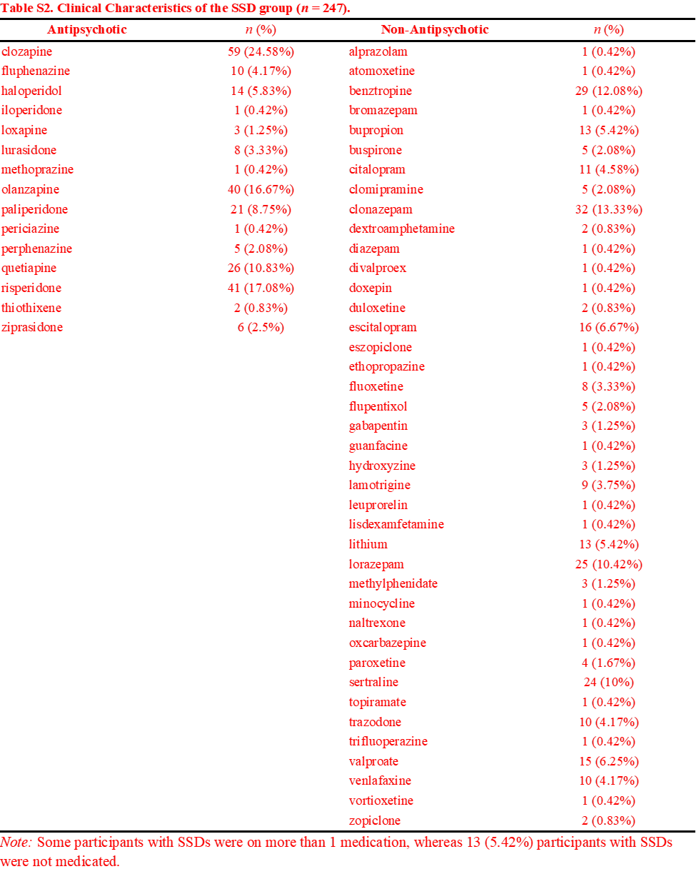

*- The results regarding the relationship between network gradients and cognitive function could have been better presented if three 'sets' of results were shown: 1) in the SSD group only, in the HC group only, and 3) in the combined groups. Such a comparison would clearly show whether there are typical relationships specific to the schizophrenia spectrum, or whether network data simply correlate with cognitive functioning in a way that is not specific to a specific clinical group.*

Thank you for the suggestion! We performed separate PLSCs to examine the cognition-gradient associations within each group (see the figure below) and also attached **Figure 3** for reference to the combined PLSC. The first PLSC dimensions from both separate PLSCs identified the general association between cognitive performance and the gradients (**A-B** and **D-E**). From these two PLSCs, we identified different contributing brain region gradients, partly in different directions (**B** and **E**). However, when we masked the contributing gradients according to the original combined PLSC, **C** and **F** showed a consensus of the contributing gradients. This result suggests that there are specific ROI gradients for the participants with SSDs, but common gradient ROI contributions were identified with a larger sample size boosting the power of the analysis. In addition, although the contributing gradients identified in the combined PLSC were found in both groups when considered separately, they still significantly differentiate the two groups (**Figure 3C**).

We have modified the **Discussion** as follows:

“The PLSC results revealed the association between compressions along three gradients and the group differences between SSDs and Controls in both social and non-social cognitive abilities; similar associations were found in separate PLSCs respectively on each group, suggesting that the results were not driven by SSDs (see **Supplementary Materials** and **Figure S8**).” – p. 10

The results were added to the **Supplementary Materials** in the **Result** section, along with **Figure S8**:

“***Separate PLSCs for Controls-Only and SSDs-Only Identified Similar Cognition-Gradient Associations***

To understand if the observed cognition-gradient association was a general relationship or a specific one for SSDs, we performed separate PLSCs to examine these associations within each group. The results are shown in **Figure S8**, referencing **Figure 3** for the same results when the two groups are combined. Results showed that the first PLSC dimensions from both separate PLSCs identified the general association between cognitive performance and the gradients (**Figures S8A-S8B** and **S8D-S8E**). From these two PLSCs, we identified different contributing brain region gradients, partly in different directions (**Figures S8B** and **S8E**). However, when we masked the contributing gradients according to the original combined PLSC, **Figures S8C** and **S8F** showed a consensus of the contributing gradients. This result suggests that there are specific ROI gradients for the participants with SSDs, but common gradient ROI contributions were identified with a larger sample size boosting the power of the analysis. In addition, although the contributing gradients identified in the combined PLSC were found in both groups when considered separately, they still significantly differentiated the two groups (**Figure 3C**).”– Supplementary Materials p. 7

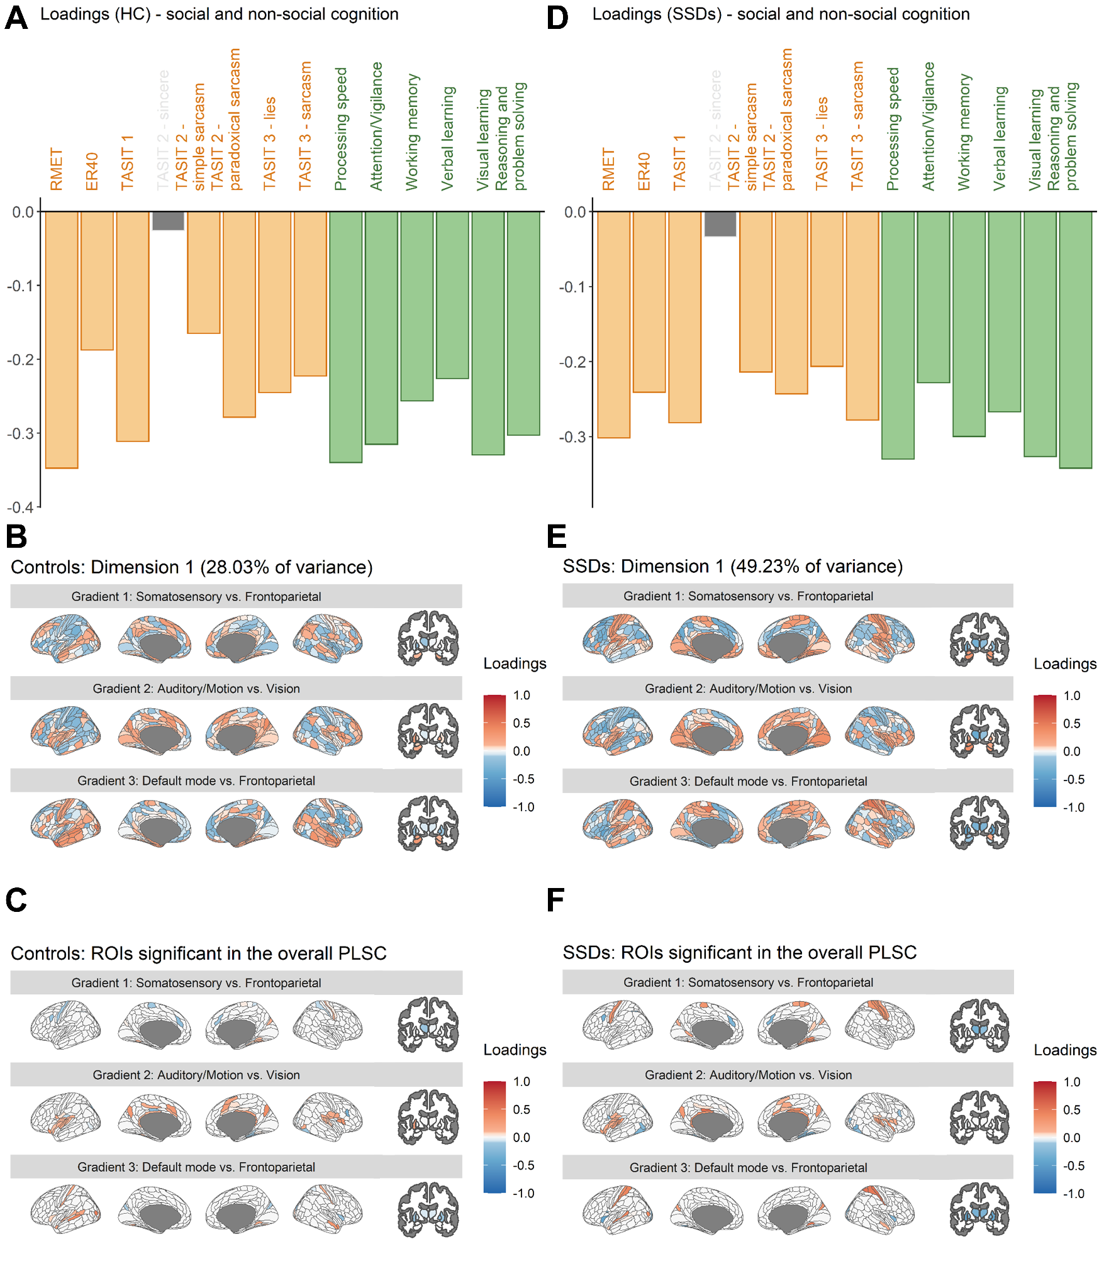

**Figure S8. PLSC results with only Controls or the participant with SSDs. A**-**C** illustrates the loadings from the Controls-only PLSC, and **D-F** illustrates the loadings from the SSDs-only PLSC. The loadings for the cognitive measures (**A** and **D**) and the network hierarchy (**B** and **E**) separately from the two groups both illustrate the general associations of the cognitive measures and the network hierarchy. **C** and **F** showed the loadings, respectively from **B** and **E**, masked by the contributing gradient regions of interest (ROIs) identified by the combined PLSC (**Figure 3B**).

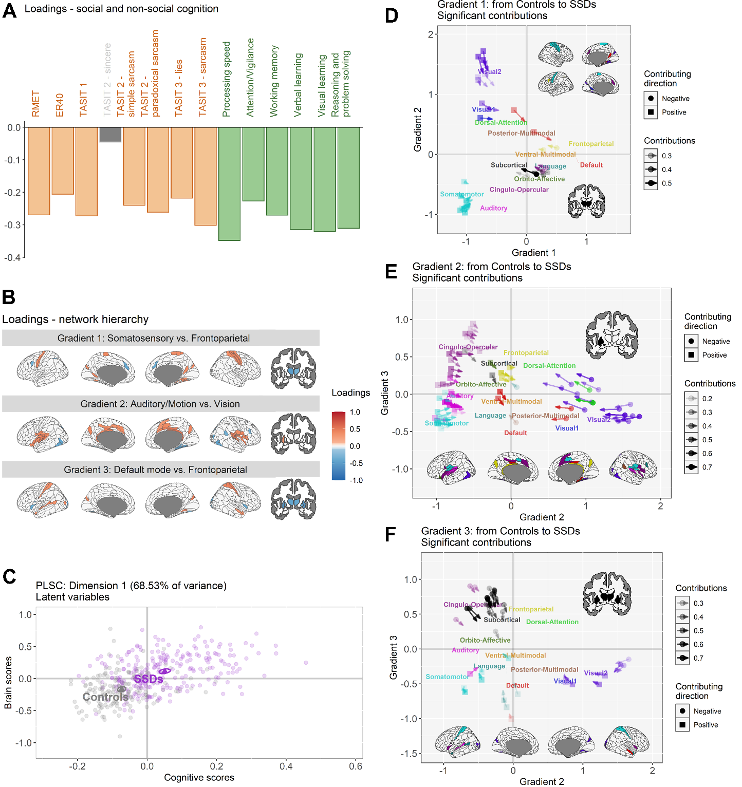

**Figure 3**

*- The results indicating that altered compression patterns involving sensory networks significantly explained the generalized cognitive deficit in schizophrenia are the most interesting and, in my opinion, the most valuable finding of this study. This is somewhat at odds with a significant number of results showing a relationship between cognitive function and large-scale task networks such as the FPN or CEN.*

We thank the reviewer for their interest in our results. Originally, we were also expecting more task-related networks to be associated with cognitive function. Their absence in our analysis could be due to (1) the use of the gradient framework, (2) the use of PLSC, and (3) the use of resting-state fMRI data.

Although gradient analysis generates connectivity patterns, such analysis projects patterns onto a specific multivariate framework, to which the interpretation and findings are also constrained. The task-related networks, mostly the ones related to higher-order cognition, are more likely to be identified when the differences between them and the lower-order cognitive networks (for Gradient 1) or the subcortical networks (for Gradient 3) are prominent enough to be identified. Furthermore, with PLSC decomposing such cognition-gradient association patterns, task-related networks, although contributing to the dimension, were not stable enough to reach the significant level after correction for multiple comparisons. The contribution of these networks might be distributed to other dimensions in PLSC. Finally, we think the use of resting-state connectivity might lead to a smaller variance in the connectivity of these networks, therefore shadowing the effects.

*And in the end, the most important problem: schizophrenia is already a well-known disconnection disorder. So, it is quite easy to expect that a comparison between such a clinical group and control group regarding neural network organization will bring significant differences. On the other hand, since cognitive dysfunction in schizophrenia are also very well presented, it is also quite easy to obtain correlations between network measures and cognitive indexes. So, the general results of this study are possible to predict even without empirical testing. Of course, such predictability does not concern details, but again, the details are heterogenous.*

We thank the reviewer for raising this concern. We agree that the results are not surprising, but we think that the merit of this study is to be able to identify correlations with specific networks and cognition, especially including multiple aspects of social cognition. It is also worth knowing that the brain-behavioral relationships still relate to the clinical outcomes even when the participants are under treatment and are stable.

We have reworded to strengthen this point in the **Discussion** as follows:

“Overall, although the brain-cognition association was expected, our study, with rich brain, behavioral, and functioning data with advanced multivariate methods, identified specific network changes and included multiple aspects of social cognition, along with clinical and functional measures. Clinical and functional relevance of brain-cognitive associations in stable participants with SSDs further suggest their role in the psychopathology and functioning of SSDs.” – p. 10

**Reviewer 4:** Comments to authors:  
*In this manuscript, Yu et al. examined relationships between functional connectivity gradients and cognition in a fairly large sample of people with schizophrenia spectrum disorders (SSD). They identified 3 such gradients, each of which was less differentiated in SSD than in controls. Moreover, the first gradient was positively correlated with negative symptoms and functioning in the patient group. The manuscript covers important work and is well done, with some of the methods being developed by co-authors. In addition, they do a good job comparing their results to those for other diagnoses. The paper is also well written. However, I do have a number of concerns.  
  
First, the Abstract should include the final sample rather than the sample they started with. In the Results section, they state that they ended up with 248 people with SSD and 172 controls. As a related point, they should examine whether excluded participants differed in any systematic way from those who were retained.*

We thank the reviewer for the suggestion and have revised the **Method** section as follows:

“In total, 274 participants with SSDs and 172 Controls from the SPINS study were analyzed (37).” – p. 5

Regarding the excluded participants, they were mostly removed due to ineligibility or early termination (*n* = 71), missing MRI data (*n* = 42; most of them due to a later withdrawal), missing cognitive data (*n* = 30; most of them due to a later withdrawal), or poor imaging quality for the resting-state scans (*n* = 15). Given most of the participants who did not end up in the final analysis were due to lack of data, understanding the systematic differences is a challenge. In relation to poorer imaging quality, they were mostly due to issues in data acquisition.

*Second, in the Introduction (lines 32-33), the authors state that "decreased segregation is represented by networks moving toward the center from both ends of the gradient axes . . ." It should be clarified whether they mean this in a mathematical sense (e.g., less broad distribution of scores) or spatially (reduced spatial distribution of the gradients), or something else.*

We thank the reviewer for the feedback. We meant the decreased segregation in the mathematical sense. We have clarified and reworded the sentence as follows in the **Introduction**:

“Human behaviors and cognitions are often generated from the coordinated functioning of different brain regions (4), which is closely linked to the geometry of brain (5). Gradient analysis provides a multivariate framework where the dimensions (i.e., the gradients) are aligned with geodesic brain features (3) and are found meaningful biologically (6–8), developmentally (9,10), and evolutionarily (11). These extracted gradient scores represent the organization of brain regions along hierarchical levels which map onto different levels of cognition. Although the interpretation of scores may be open to debate, higher gradient scores in opposite directions on a gradient represent greater segregation of networks along the corresponding hierarchical network level. When represented by a scatter plot, the lower segregation is represented by networks having gradient scores closer to 0 on the axes resulting in a lower variance of the overall gradient scores, thus called ‘gradient compression.’ With such interpretation, gradient analysis has been used to examine how functional connectivity relates to cognition; e.g., creativity performance (12) and semantic cognition (13,14), where the neurocognitive system of semantic cognition was found to also regulate social cognition (15).” – p. 3

*Third, in the paragraph on Social and non-social cognition in SSD, the authors cite their own work, but there is a very extensive literature on such deficits in SSD, and they should cite some of that.*

Thank you for the suggestion! We have cited more literature in addition to the ones we have in the **Introduction**:

“Social and non-social cognition are critically important to functioning in people with SSDs (28–31). Previous literature (32–35), including work by our group (2,26), suggests that non-social cognitive performance, and particularly social cognitive performance, may relate to network segregation in people with SSDs.” – p. 3

28. Fett A-KJ, Viechtbauer W, Dominguez M-G, Penn DL, Van Os J, Krabbendam L (2011): The relationship between neurocognition and social cognition with functional outcomes in schizophrenia: A meta-analysis. *Neurosci Biobehav Rev* 35: 573–588.

29. Couture SM (2006): The Functional Significance of Social Cognition in Schizophrenia: A Review. *Schizophr Bull* 32: S44–S63.

30. Green MF, Kern RS, Heaton RK (2004): Longitudinal studies of cognition and functional outcome in schizophrenia: implications for MATRICS. *Schizophr Res* 72: 41–51.

31. Green MF, Horan WP, Lee J (2019): Nonsocial and social cognition in schizophrenia: current evidence and future directions. *World Psychiatry* 18: 146–161.

32. Mier D, Eisenacher S, Rausch F, Englisch S, Gerchen MF, Zamoscik V, *et al.* (2017): Aberrant activity and connectivity of the posterior superior temporal sulcus during social cognition in schizophrenia. *Eur Arch Psychiatry Clin Neurosci* 267: 597–610.

33. Green MF, Horan WP, Lee J (2015): Social cognition in schizophrenia. *Nat Rev Neurosci* 16: 620–631.

34. Friston KJ, Frith CD (1995): Schizophrenia: a disconnection syndrome. *Clin Neurosci* 3: 89–97.

35. Choe E, Lee TY, Kim M, Hur J-W, Yoon YB, Cho K-IK, Kwon JS (2018): Aberrant within- and between-network connectivity of the mirror neuron system network and the mentalizing network in first episode psychosis. *Schizophr Res* 199: 243–249.

*In the Methods section, the MRI resting sequence is fairly short (7 minutes). This should be added to the section on Limitations (which should be denoted as such in the Discussion). Moreover, participants had their eyes closed during the scan. Was wakefulness verified in any way?*

We thank the reviewer for the suggestions and have revised our **Discussion** accordingly, including addressing the limitation due to the short scanning time:

**“Limitation**

[…] Additional considerations include the lower signal-to-noise ratio of 7-minute resting-state scans, potential noise from using brain atlases derived from healthy participants (80), and the debated impact of global signal removal. […]” – p. 11

We have also added the data for wakefulness in the **Supplementary Materials** with a statement in the **Method** section.

“Participants were instructed to let their mind wander with their eyes closed (wakefulness information is included in **Supplementary Materials**).” – p. 5

“***Wakefulness during the RS scans***

To verify wakefulness during the RS scans, we collected responses to two questions: “*Did participant appear to fall asleep?*” and “*Did participant report falling asleep when asked?*” Among 172 Controls, 8 participants appeared to have fallen asleep during the scan with 6 of them and another 3 participants reporting it; among the 247 participants with SSDs, 16 appeared to have fallen asleep during the scan with 10 of them and another 5 participants reporting it. Overall, 32 participants (7.64%), including 11 (6.40%) Controls and 21 (8.50%) participants with SSDs, have fallen asleep during the scan.” – Supplementary Materials p. 2

*Also in the Methods, I note that global signal was used as a nuisance regressor. There has been a long standing controversy about whether this induces negative FC, as well as whether the signal is heterogeneously distributed across the brain. They should justify their use of the regressor and/or include it in the Limitations section.*

We thank the reviewer for raising this concern. We have addressed this limitation in the **Discussion**:

**“Limitation**

[…] Additional considerations include the lower signal-to-noise ratio of 7-minute resting-state scans, potential noise from using brain atlases derived from healthy participants (80), and the debated impact of global signal removal. […]” – p. 11

We have also added the justification in the **Supplementary Materials**:

“We regressed out the mean global signal to reduce the impacts of motion-related and respiratory-related artifacts (14–16).” – Supplementary Materials p. 2

14. Parkes L, Fulcher B, Yücel M, Fornito A (2018): An evaluation of the efficacy, reliability, and sensitivity of motion correction strategies for resting-state functional MRI. *NeuroImage* 171: 415–436.

15. Power JD, Plitt M, Gotts SJ, Kundu P, Voon V, Bandettini PA, Martin A (2018): Ridding fMRI data of motion-related influences: Removal of signals with distinct spatial and physical bases in multiecho data. *Proc Natl Acad Sci* 115. <https://doi.org/10.1073/pnas.1720985115>

16. Li J, Kong R, Liégeois R, Orban C, Tan Y, Sun N, *et al.* (2019): Global signal regression strengthens association between resting-state functional connectivity and behavior. *NeuroImage* 196: 126–141.

*The Results are very interesting, as I said earlier, but I found some of them to be counterintuitive. For example, in the legend for Figure 1A, the authors state that "Warm colors indicate SSDs being significantly closer to, respectively, for each gradient, the frontoparietal, the vision, or the frontoparietal networks than Controls." The Figure itself says the comparison is Controls > SSD, which would suggest just the opposite. The authors should clarify for the reader what the plotted data actually mean (i.e., do higher scores mean more less differentiated networks, which would be counterintuitive, or do they mean closer to one part or the other part of the gradient as seems more likely?). Similarly, on line 23 of the 2nd page of the results, the authors state that "On Gradient 2, the identified ROIs within DMN were those medial regions closer to FPN and temporal regions closer to VIS." What does closer mean in this context? Less different, or literally physically closer? In general, the meaning of gradient scores should be made clearer, as should how they lead to interpretations of network differentiation between groups.*

We have clarified this in the **Result** section and corrected the figure caption as follows to avoid confusion:

“[…] For Gradient 3 (default vs. frontoparietal networks), PLSC identified ROIs from the perceptual, language, and subcortical networks, where lower differentiations of SSDs were found between the unimodal networks (i.e., VIS and SMN) and LAN versus SUB. Interestingly, the identified ROIs of Gradient 3 from SMN, CON, and AUD networks were also those that were located close to LAN in the brain. […]” – p. 9

Given word limit, we have moved the original results regarding the default mode network to **Supplementary Materials**:

“***Lower Within-Network Differentiation in the Default Mode Network (DMN) Across Gradients in SSDs vs. Controls***

Although participants with SSDs have reliably higher gradient scores compared to Controls for ROIs from the default mode network (DMN), these ROIs have different patterns from those of the other networks. Descriptively, the ROIs from other networks showed lower differentiation between networks for participants with SSDs, whereas the ROIs from DMN showed lower differentiation within the network for participants with SSDs, as indicated by red arrows moving towards each other or the mean scores in **Figures 2B**-**2D**, **S4** and **S5**. Similar to Gradient 1, we also see lower within-network differentiation in DMN (see **Figures S4** and **S5**).

Given the heterogeneity of ROIs in the DMN, it is worth noting that these identified DMN ROIs identified for Gradient 1 are those that are located closer to the visual networks in the brain. On Gradient 2, the identified ROIs within DMN were those medial regions located closer in the brain to FPN and temporal regions located closer in the brain to VIS.” **–** Supplementary Materials p. 6

**“Figure 2. Group differences in Gradients 1-3. A** shows the brain regions with significant group differences according to two-sample *t*-tests (as linear models). Warm colors indicate Controls being significantly closer than SSDs to the positive ends of the gradients (i.e., the default/frontoparietal, the visual, and the frontoparietal networks, respectively); cold colors indicate Controls being significantly closer than SSDs to the negative ends of the gradients (i.e., the somatosensory/visual, the auditory/motor, and the default mode networks, respectively).”

*In the Discussion, the authors should cite some of the broad literature by other groups showing sensory abnormalities in SSD in addition to their own work.*

We thank the reviewer for the suggestion. We have now included more citations to address the sensory abnormalities findings in SSDs in the **Discussion**:

“These findings are consistent with stronger thalamic-sensorimotor connectivity in SSDs as opposed to Controls in previous literature (65–67) and aligned with previous literature that demonstrated the relationships between abnormal thalamic connectivity and sensory abnormalities (68,69). Together, these results support the hypothesis proposed by Andreasen et al. (70) that the dysfunction of the cortical-subcortical-cerebellar circuit (with thalamus being one of the main nodes) contributes to symptoms and cognitive deficits in SSDs.” – p. 10

65. Anticevic A, Cole MW, Repovs G, Murray JD, Brumbaugh MS, Winkler AM, *et al.* (2014): Characterizing Thalamo-Cortical Disturbances in Schizophrenia and Bipolar Illness. *Cereb Cortex* 24: 3116–3130.

66. Damaraju E, Allen EA, Belger A, Ford JM, McEwen S, Mathalon DH, *et al.* (2014): Dynamic functional connectivity analysis reveals transient states of dysconnectivity in schizophrenia. *NeuroImage Clin* 5: 298–308.

67. Woodward ND, Karbasforoushan H, Heckers S (2012): Thalamocortical Dysconnectivity in Schizophrenia. *Am J Psychiatry* 169: 1092–1099.

68. Abram SV, Hua JPY, Ford JM (2022): Consider the pons: bridging the gap on sensory prediction abnormalities in schizophrenia. *Trends Neurosci* 45: 798–808.

69. Behrendt R-P, Young C (2004): Hallucinations in schizophrenia, sensory impairment, and brain disease: A unifying model. *Behav Brain Sci* 27: 771–787.

70. Andreasen NC, Paradiso S, O’Leary DS (1998): “Cognitive Dysmetria” as an Integrative Theory of Schizophrenia: A Dysfunction in Cortical-Subcortical-Cerebellar Circuitry? *Schizophr Bull* 24: 203–218.

*Minor points:  
One line 43 of the Discussion, the authors should state in whom increased thalamic-sensory connectivity is shown, as it indicates a comparison.*

We have added the information accordingly:

“These findings are consistent with stronger thalamic-sensorimotor connectivity in SSDs than Controls in previous literature (57–59) [...]” – p. 10 *In general, "increased" and "decreased" should be avoided unless the data are longitudinal. Preferred terms are "higher" and "lower."*

We have reworded the manuscript according to the suggestion.